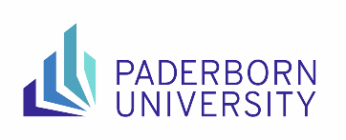
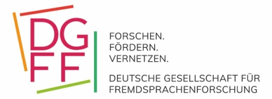

Building Bridges - Perspectives and Potentials in
Foreign Language Research

16th DGFF Conference for Early Career Researchers
16 & 17 September 2024

Call for Papers
University of Paderborn

In an age of global networking and connectivity, building bridges among languages, disciplines, fields, and their associated cultures continues to gain momentum. With this in mind, the TEFL team at Paderborn University cordially invites you to the 16th Early Career Researchers' Conference of the German Association for Foreign Language Research (DGFF).
The conference offers academics in the field of second and foreign language research a platform to present their research projects and provides you with the opportunity to network and engage with expert researchers. We welcome presentations from the diverse fields linked to English language education and invite you to connect and build bridges.

Two presentation formats are available:

1. Presentation with project discussion:
Within thematic strands, researchers will be able to present their work-in-progress projects and engage in extensive discussions. Expert researchers in the respective topic will lead panel sessions with concurrent segments (featuring 20-minute presentations followed by discussion). In this format, you can present data, research instruments and designs and receive valuable feedback.

2. Project consultations with experts in small groups:
Individual project consultations in small groups with experts are offered for doctoral students in the initial stages of a PhD project. In this early phase of your doctorate, you will receive suggestions and ideas on research approaches and methodological decisions.

In addition, workshops are also held on various foreign language education topics. The following experts have already confirmed their participation:

Prof Dr Marcus Callies (University of Bremen)
Prof Dr Stefanie Frisch (University of Wuppertal)
Prof Dr Lena Heine (Ruhr University Bochum)
Prof Dr Peter Hohwiller (University of Paderborn)
Prof Dr Frauke Matz (University of Münster)
Prof Dr Thorsten Merse (University of Duisburg-Essen)
Prof Dr Heike Niesen (University of Leipzig)
Junior Professor Dr Julia Reckermann (University of Münster)
Prof Dr Henning Rossa (University of Trier)
Prof Dr Dominik Rumlich (University of Paderborn)
Junior Professor Dr Victoria del Valle (University of Paderborn)
Prof Dr Katharina Wieland (Martin Luther University Halle-Wittenberg)

We would like to explicitly invite doctoral students who have little presentation experience and whose projects are still in the early stages. One contribution per person can be submitted as lead author. Contributions can be submitted from 01 February 2024 to 30 April 2024 using the Indico registration tool available on the website: https://go.uni-paderborn.de/dgffnt24.

Please note that abstracts are limited to 300 words (excluding title and literature). Please provide three to five keywords so that your contribution can be categorised thematically. We also kindly ask you to indicate a preference for which format (presentations or project consultations) you would like to submit your contribution. We will try our best to accommodate your preference accordingly.

We also welcome researchers who are not planning to present at the conference. Please also register by 15 August 2024 via the registration tool on the website
https://go.uni-paderborn.de/dgffnt24. Registration is expected to open from mid-March 2024.

Further information can be found on the conference website
https://go.uni-paderborn.de/dgffnt24. If you have any questions, please contact us directly at dgffnt24@upb.de.

We look forward to your contributions and to building bridges with you to new perspectives and potentials in foreign language research!

